# Purchase Numbers

Lineblocs currently offers voice numbers that are toll-free, local or vanity based. You can use the Lineblocs user dashboard to buy new DID numbers in a supported rate centre and region.

## Searching for numbers

1. In [Lineblocs dashboard](https://app.lineblocs.com/#/dashboard) click ["DID Numbers" -> "Buy Numbers"](https://app.lineblocs.com/#/dashboard/dids/buy-numbers)
2. Select Voice Numbers
3. Search for numbers based on the filters provided. Click "More Options" for advanced filters 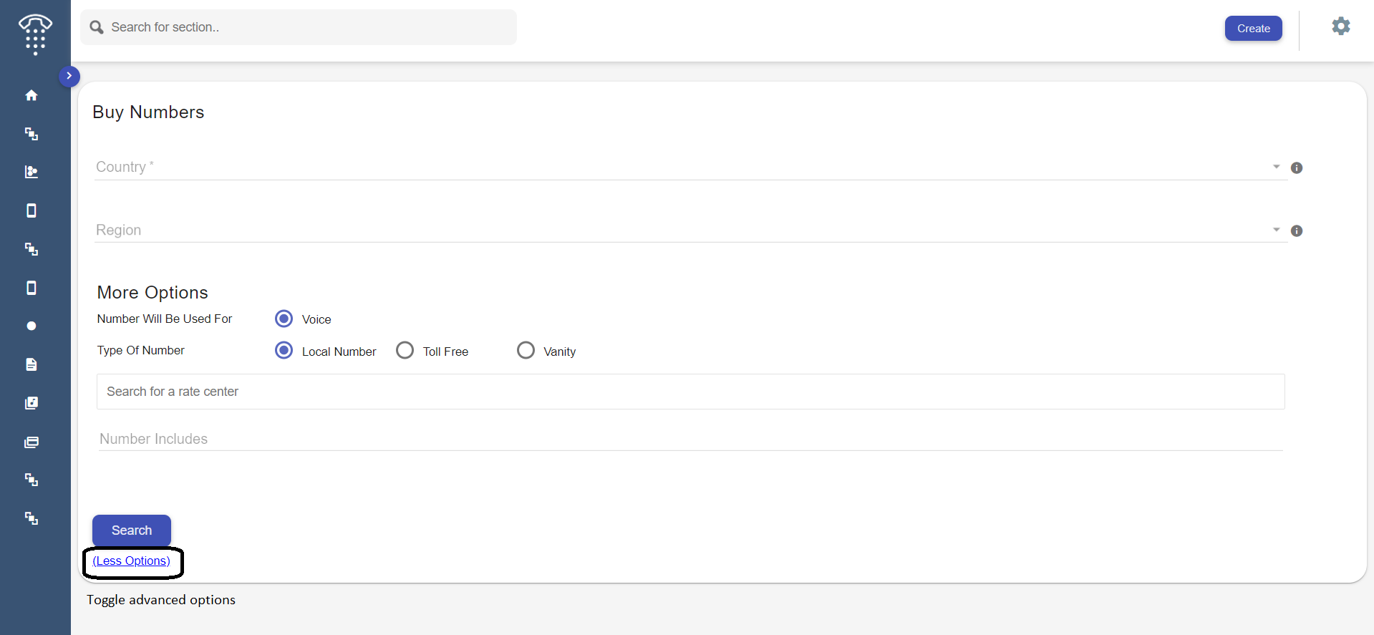
4. Click Search

## Buying a number

To purchase a number, click the IMG_257 button next to the number.

## Setup Number

Once you have purchased a new number, you can change the number's settings according to your needs – including changing its label, call flow, and more. For more info on managing numbers, please [click here](https://lineblocs.com/resources/managing-numbers/manage-numbers)

## Next Steps

For related guides, please see the following:

* [Porting Numbers](https://lineblocs.com/resources/managing-numbers/porting-numbers)
* [Releasing Numbers](https://lineblocs.com/resources/managing-numbers/release-numbers)